REST API

🔹 What is a REST API?
# Source: AI Source: Provided by: [Data Path: Persons Table -> ID Column: 1, Name_En Column: Motasem Essam] -> From: [ChatGPT] on [1/19/2026]
A REST API (Representational State Transfer Application Programming Interface) is a set of rules that allows different software applications to communicate with each other over the internet using HTTP.
It’s a common way for web services and mobile apps to request or send data to a server.

✅ Key Concepts:
# Source: AI Source: Provided by: [Data Path: Persons Table -> ID Column: 1, Name_En Column: Motasem Essam] -> From: [ChatGPT] on [1/19/2026]
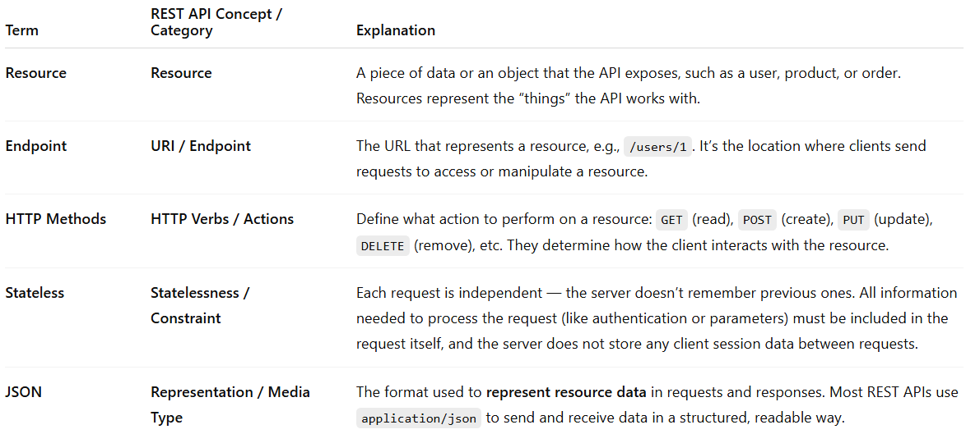
Term | REST API Concept / Category | Explanation
Resource | Resource | A piece of data or an object that the API exposes, such as a user, product, or order. Resources represent the “things” the API works with.
Endpoint | URI / Endpoint | The URL that represents a resource, e.g., /users/1. It’s the location where clients send requests to access or manipulate a resource.
HTTP Methods | HTTP Verbs / Actions | Define what action to perform on a resource: GET (read), POST (create), PUT (update), DELETE (remove), etc. They determine how the client interacts with the resource.
Stateless | Statelessness / Constraint | Each request is independent — the server doesn’t remember previous ones. All information needed to process the request (like authentication or parameters) must be included in the request itself, and the server does not store any client session data between requests.
JSON | Representation / Media Type | The format used to represent resource data in requests and responses. Most REST APIs use application/json to send and receive data in a structured, readable way.

🔍 Example:
# Source: AI Source: Provided by: [Data Path: Persons Table -> ID Column: 1, Name_En Column: Motasem Essam] -> From: [ChatGPT] on [1/19/2026]
Imagine a REST API for a library:
- GET /books → Get a list of books
- GET /books/123 → Get info about the book with ID 123
- POST /books → Add a new book
- PUT /books/123 → Update book 123
- DELETE /books/123 → Delete book 123
Each of these actions is done through HTTP requests to a specific endpoint.

🔧 Why REST APIs Are Useful:
# Source: AI Source: Provided by: [Data Path: Persons Table -> ID Column: 1, Name_En Column: Motasem Essam] -> From: [ChatGPT] on [1/19/2026]
- Easy to use and integrate with web and mobile apps.
- Platform-independent (works with any language or system).
- Uses standard web protocols.

